**References**

From Snyder and Kick:

* Development explanation – “Many development explanations treat economic growth largely as a process endogenous to nations and as an ordered sequence in which currently poor countries can repeat the strategies and experiences of wealthy nations” “… reduce consumption, increase savings, investment and capital formation” They are not completely exogenous – “economic development in poor nations is enhanced by importation of investments and by direct forms of aid (money and technical knowledge”
* “There is a little difference in stratification”
* World is core, semiperiphery and periphery
* Core exploits semi and peri
* Dollar value of nation’s exports and imports as a percentage of GDP helps countries like USA and Japan to be a core.
* World system is capitalist
* White – general theme that actors’ behaviors are influenced by their positions in a social structure is a venerable one and has generated various methods of representing structure and position empirically.
* Advantages of block model for international interactions: relative durability and nonreactivity of recorded information on interactions, inclusion of almost all actors in the population of interest

From Breiger:

* Can operational procedures be developed to identify core, peri, semi on structural positions in international exchange networks? In what sense are the core-periphery
* “world system theorists partition the grid of unequal exchange relations into three general zones or positions identified on the basis of world market trade in bulk commodities that are necessities for everyday consumption. In brief: core states appropriate the surplus of the world economy as a whole and in particular of those states located in the periphery, which produce ‘lower-ranking’ labor intensive goods, while states located in the semi periphery are both exploited and exploiters.
* “natural wedding between world-system theory and a general analytical strategy for the analysis of multiple networks, termed block model analysis”
* “International trade is represented as a matrix reporting trade among all pairs of nations with respect to given commodity type and a given time period”

Things to go over:

Method: Why block model?

Random Ideas:

* Blockmodeling examples from International Trade
* Structural position in network theory – what is it?
* Structural Role of Japan in World Economy
* 3 level analysis
  + Level 1 – country’s background
  + The top export destinations of Japan are [China](https://oec.world/en/profile/country/chn/) ($136B), [the United States](https://oec.world/en/profile/country/usa/) ($125B), [South Korea](https://oec.world/en/profile/country/kor/) ($54.2B), [Other Asia](https://oec.world/en/profile/country/)($32.9B) and [Hong Kong](https://oec.world/en/profile/country/hkg/) ($32.1B). The top import origins are [China](https://oec.world/en/profile/country/chn/) ($157B), [the United States](https://oec.world/en/profile/country/usa/) ($66.9B), [Australia](https://oec.world/en/profile/country/aus/) ($34.6B), [South Korea](https://oec.world/en/profile/country/kor/) ($26.9B) and [Saudi Arabia](https://oec.world/en/profile/country/sau/) ($25B).
  + Level 2 – block model - Use CONCOR
  + Level 3 – dynamic history
* Does the type of exports and imports have an effect in core-periphery structure?
* What impact has including adding data from China and India have on Breiger’s argument?
* Economic growth of Japan
  + economic interventionism of the Japanese government and partly due to the aid and assistance of the U.S. Marshall Plan.
  + the recovery (1946–1954), the high increase (1955–1972), the steady increase (1972–1992), and the low increase (1992–2017) the recovery (1946–1954), the high increase (1955–1972), the steady increase (1972–1992), and the low increase (1992–2017)
* Objective:
  + Replicate Breiger with OECD, Isreal, New OECD, India, China, Brazil

<https://unstats.un.org/unsd/publication/SeriesM/SeriesM_34rev4E.pdf>

<https://unstats.un.org/unsd/tradekb/Knowledgebase/EBOPS-2002>

Analysis:

Block Model Analysis

2018 data

1990 data

Block together countries that have the most similar sets of trading partners with respect to both imports and exports

Breiger’s study:

Strong center-periphery pattern:

Aggregate pattern – first listed block has extensive trade (both imports and exports) with each other block except the last.

“rows and columns were subtracted from each matrix, leaving residuals from an additive, two way analysis of variance model. Entries greater than zero indicate positive (statistical) interactions for the trade of a given commodity between pairs of countries, and conversely for negative values.

CONCOR algorithm was applied simultaneously to the rows and columns of these 3 matrices

The whole idea of "equivalence" that we discussed in the last chapter is an effort to understand the pattern of relationships in a graph by creating classes, or groups of actors who are "equivalent" in one sense or another.

Apply 4 block concor to each of the four products

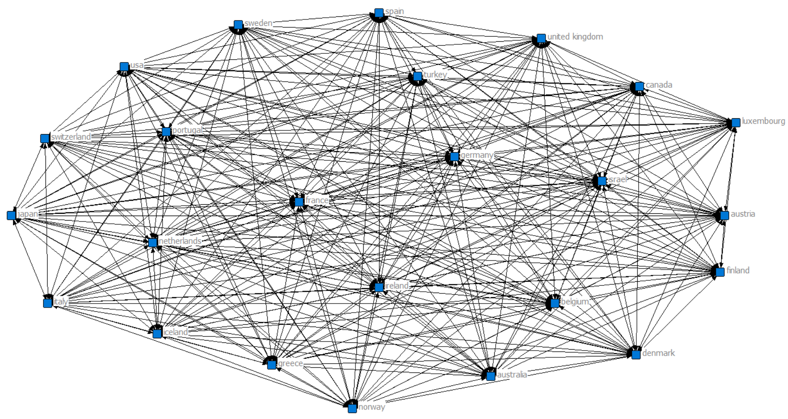

--

From Faust

Actors in a

social network are structurally equivalent if they have identical relational

ties to and from all other actors in a network.

<https://faculty.ucr.edu/~hanneman/nettext/C9_Ego_networks.html>

Structuralism

Dependency – natural resources and labor to core

World system -

Why are poor countries poor?

Acemotglu and Robinson

### Block Modelling

Block model analysis and CONCOR

### Breiger’s “Structures of Economic Interdependence Among Nations"

For his analysis, Breiger conducts a block model analysis for each of the trade networks to find partitions of groups of nations and how they trade among each other and other blocks of nations. A matrix of means of each partitioned network is found to determine on average the trade among blocks. He then forms a single partition across multiple matrices by applying the CONCOR algorithm

--

For each of the trade networks, Breiger only considers the highest fifth of the interior cell values. He then rearranges and partitions them using block-model algorithm to block together nations that have the most similar sets of trading partners, with respect to imports and exports.

Steps:

For each network, for each year:

* Binary
* Optimize

For each year:

* Make correlation matrix for 3 of them
* Adjust like schwartz
* Apply concor
* Examine Eigen Structure by plotting first two eigenvectors

C:\Users\Dhruval\AppData\Roaming\AnalyticTech\Ucinet

2008

Tables and Figures from Breiger’s Work

Christopher Chase Dunn and Dunn, Kawana, Brewer (2000)

1972

Non-Normalized & Normalized

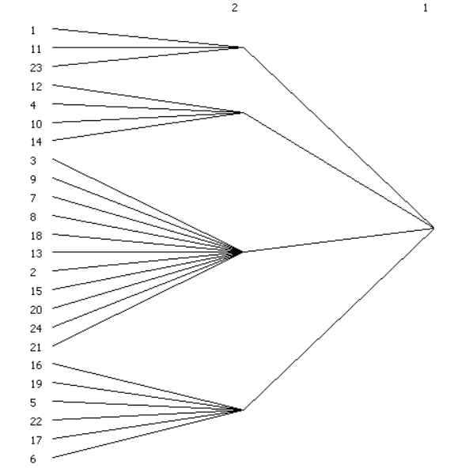 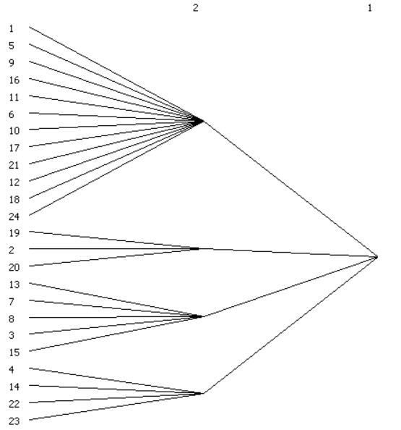

2018

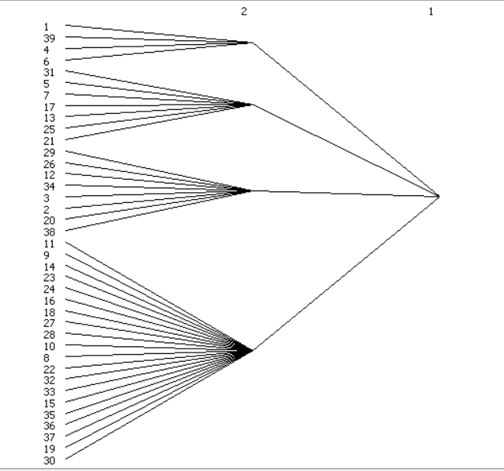

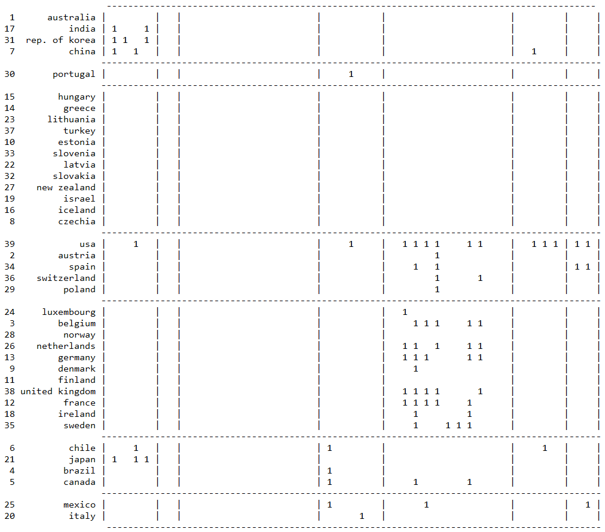

Figure 19 CONCOR Block Model for Manufacturing – 2007

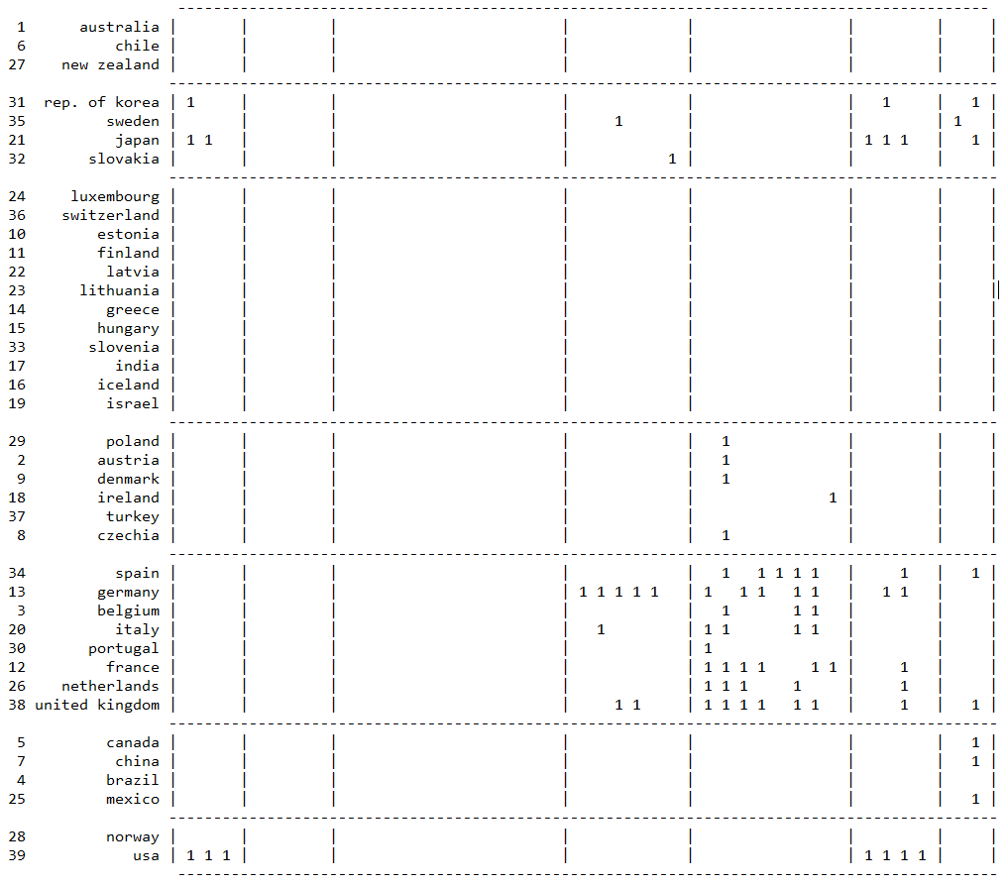

Figure 20 CONCOR Block Model for Agriculture Products – 2007

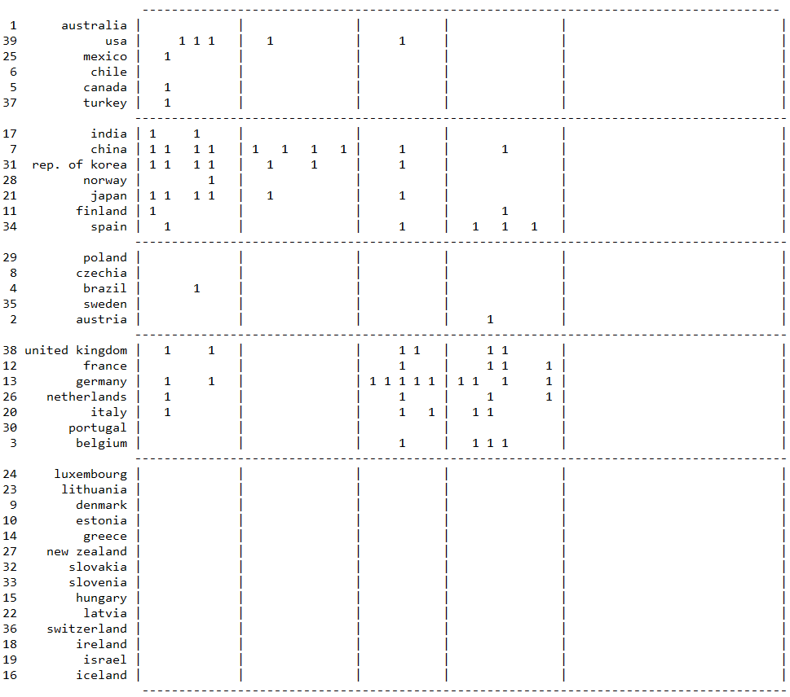

Figure 21 CONCOR Block Model for Raw Materials – 2007

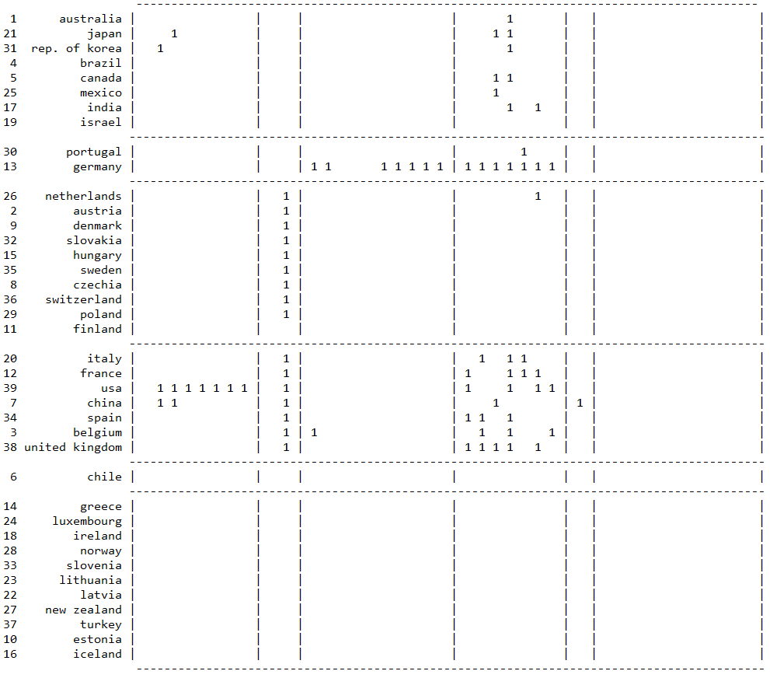

Figure 22 CONCOR Block Model for Energy Products – 2007

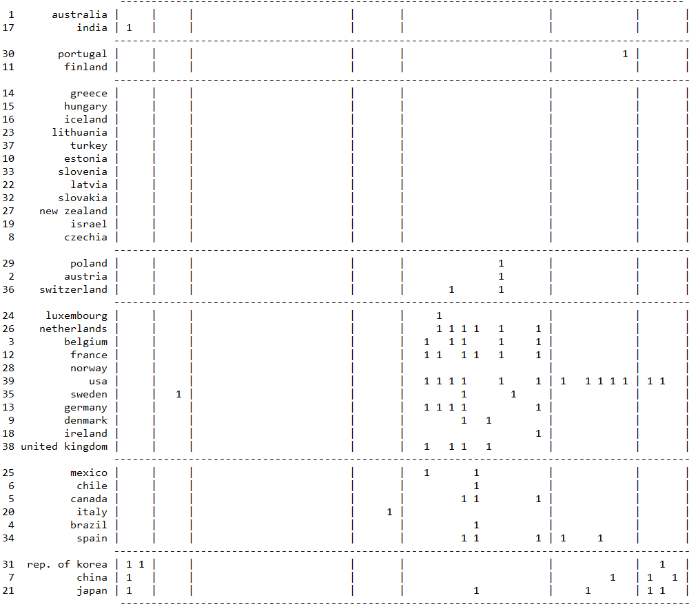

Figure 15 CONCOR Block Model for Manufacturing – 2008

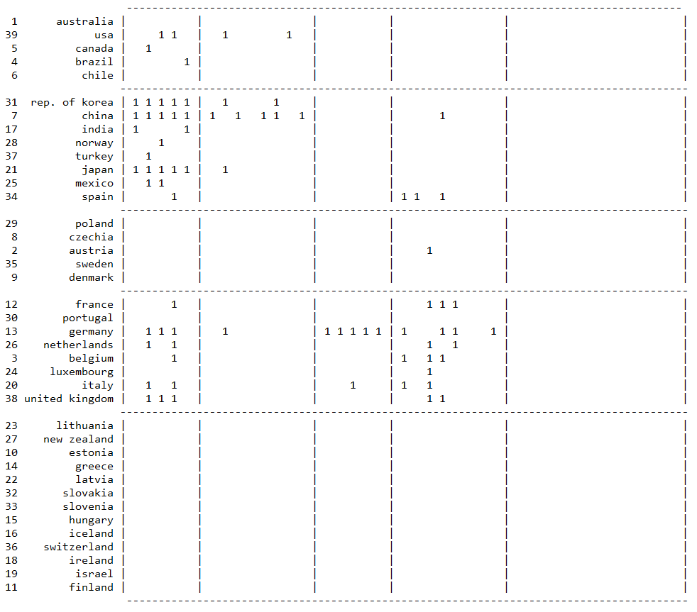

Figure 16 CONCOR Block Model for Raw Materials - 2008

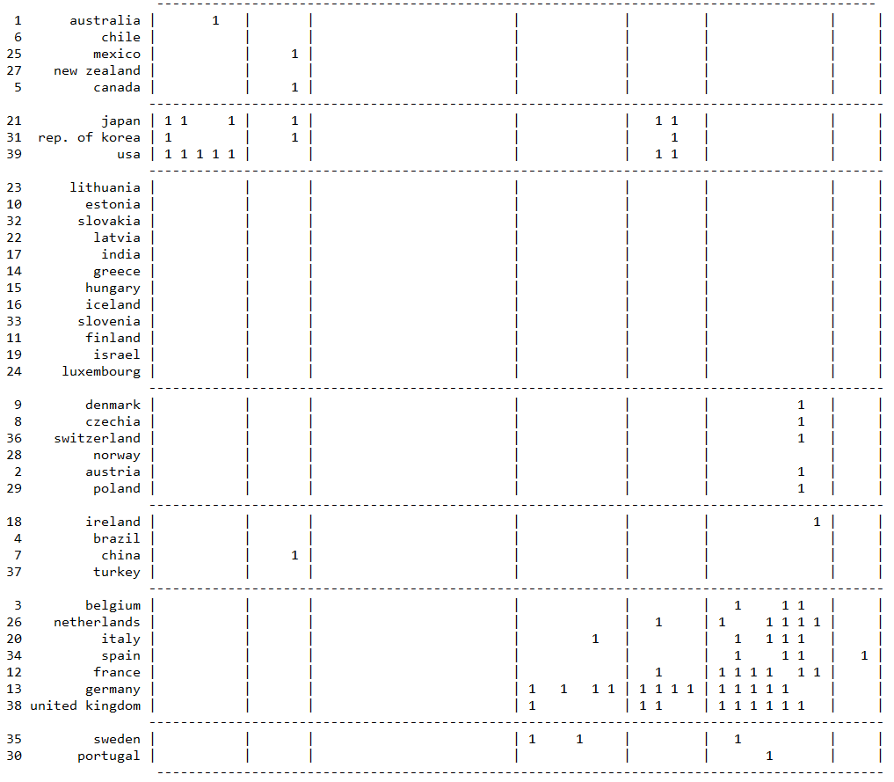

Figure 17 CONCOR Block Model for Agricultural Products – 2008

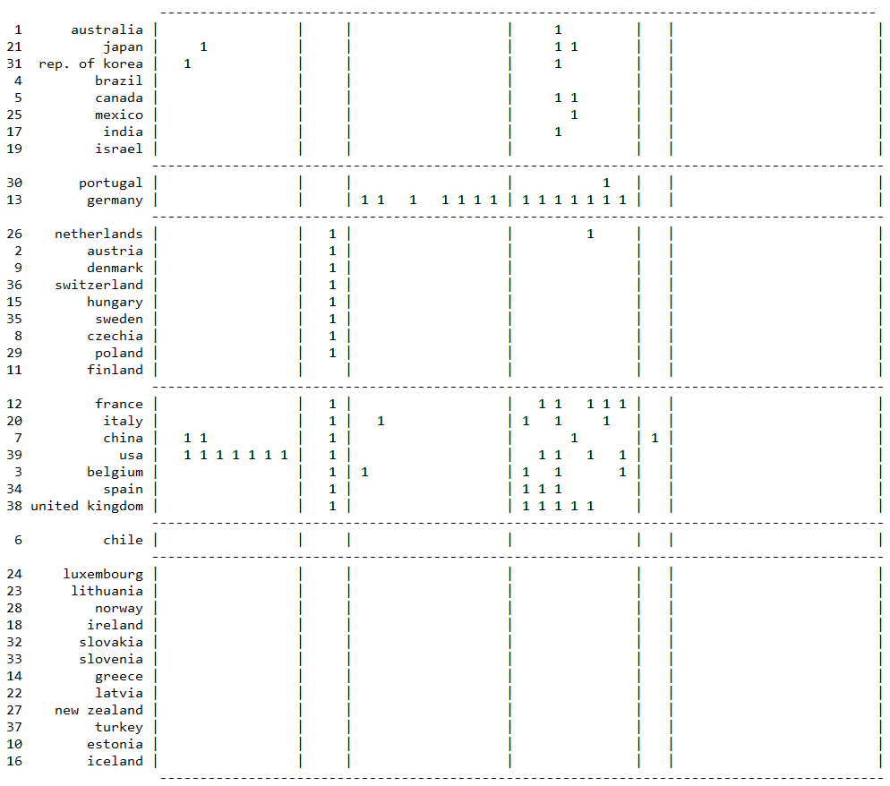

Figure 18 CONCOR Block Model for Energy Products – 2008

